|  |  |  |
| --- | --- | --- |
| Group Project Reserve Plant Species | February 15  2015 | |
| Test Report | | Group 10 |

# Web Test Report

The tests are outlined in the test spec documentation version 1.3 for both java and web. This is the Web side of the testing and is an overall summary of how the testing went.

The tests are labelled with identification IDs in the format "*WT#"* referring to it being a Web Test, followed by the numeric ID of the actual test being conducted. The specification requirements are also listed by their original requirement ID, e.g. "*FR1.*"

|  |  |  |
| --- | --- | --- |
| Test Specification Requirement | Test ID | Description |
| FR7 | WT1 | This test checks if the server can receive and store recordings sent from the android app. This has been checked by sending a recording to the server via a HTTP post. The test has been passed by giving the output of the new recording with the appropriate data. |
| FR7 | WT2 | This test checks for corrupt files or incomplete ones. The test consists of comparing the file sizes match on both sides. Test was passed by giving the correct output of file sizes. |
| FR8 | WT3 | This test will check if it is possible to add a reserve with blank text fields. Upon trying to create a new reserve with blank text fields we get three errors asking to enter a reserve name location and description. Thus the test was a success. |
| FR8 | WT4 | This tests if it is possible to add a reserve with a name longer than 64 characters. The test has been passed, displaying an error message telling the user that the reserve name is too long and stating that there is a 64 character limit. |
| FR8 | WT5 | This was tested by inputting letter instead of numbers in the coordinate’s field. The test was past because of the successful displaying of an error message saying that the user should input a valid GPS location. |
| FR8 | WT6 | This test makes sure that the text in the description area is no longer than 100 characters. Because of the error message saying that the reserve description is too long and there is a character cap of 100 the test has been passed. |
| FR8 | WT7 | This test checks the possibility of adding a new reserve to the table given proper input in all the fields. This has passed, adding the reserve and redirecting the user back to the reserves page. |
| FR8 | WT8 | By doing this test we make sure that when a reserve is selected to be edited all the stored data is displayed in the form fields. This has passed by showing all the correct data and also by taking the user to a separate page that shows all the form fields and data. |
| FR8 | WT9 | Checking that a user cannot edit the reserve name to be longer than 64 characters. It has been passed by displaying an error message saying that the reserve name is too long and not overwriting the previous form of the reserve. |
| FR8 | WT10 | The test makes sure the user cannot edit a reserve and fill it with empty fields with no data. This has been tested by selecting a reserve and deleting all the data associated with it. The test has been passed because of the displaying of the 3 errors that require the user to state a name, location and description field and also leaving the data as it previously was. |
| FR8 | WT11 | This makes sure the OS grid reference cannot be changed to text by the use of the edit button. This has been tested by editing a reserve and replacing the valid GPS location with some random text. The test has been past as it displays an error message stating the GPS location is not valid and should be entered as latitude and longitude coordinates. |
| FR8 | WT12 | The test involves checking that the description of a reserve cannot be edited in a text longer than 100 characters. This was tested by adding text in the description area so that it exceeds 100 characters. An error message was displayed saying that the limit of characters was exceeded for the description, so the test was passed |
| FR8 | WT13 | This verifies that the edit function actually works. This has been done by editing a reserve and changing all the fields with data that will be accepted (reserve name, GPS location and a proper description). The test has been passed by saving the edit and redirecting the user back to the reserves pages. |
| FR8 | WT14 | Making sure that the reserves can be deleted. This was tested by selecting a reserve from the table and using the delete function. It was passed because the selected reserve was no longer displayed in the table. |
| FR8 | WT15 | Testing that the reserves are displayed in alphabetical order. This was tested by viewing the table and making sure they are properly listed. It has passed by showing the reserves in an alphabetical order. |
| FR8 | WT16 | Check to ensure the user can log into the website with a given password and username stored in the database. The log in is successful for the given user and password. |
| FR8 | WT17 | Check to ensure that you cannot login to the website without using a username and password that are in the database. After entering a random name and password an error message is displayed stating that the login details are invalid so the test has been passed. |
| FR8 | WT18 | This test checks if once logged in the navigation changes from login to logout. After a successful login the navigation bar has updated so the test has been passed. |
| FR8 | WT19 | Once logged in you should have access to the functions only the admin can carry out. This has been checked by logging in and making sure that add, edit and delete reserves buttons have appeared. Once logged in the buttons indeed appeared so the test was successful. |
| FR8 | WT20 | While not being logged in the user should not be able to view the buttons that carry extra functions and are only for admins. While not being logged in as the admin user the reserves page is checked and the buttons for add edit and delete are not displayed on the website. Test has passed. |
| FR9 | WT21 | The test makes sure the user can search by reserve on the recordings page. After a reserve is selected from the drop menu and the search button is pressed the website displays the records that are only related to that reserve thus passing the test. |
| FR9 | WT22 | The user should be able to order the records by date after a search for a reserve has been made. This has been tested by selecting a reserve from the drop down menu and then pressing the search button. The records for the reserve are indeed ordered by the date they were added so the test has been passed. |
| FR9 | WT23 | This test check if the records table has been sorted in alphabetical order by the species Latin name. By checking the records page we can verify they are indeed stored in alphabetical order with the species name. The test has been passed. |
| FR9 | WT24 | This test makes sure that the viewing of the thumbnails and images match the load properly. This has been tested by opening the thumbnails of the scene or species making sure they match the actual image. This test has been passed. |

# Java Test Report

The tests are outlined in the test spec documentation version 1.3 for both java and web. This is the java side of the testing and is an overall summary of how the testing went.

The tests were done on a *Samsung Galaxy Note* *3* running Android 4.4.2 *KitKat*.

The tests are labelled with identification IDs in the format "*JT#"* referring to it being a Java Test, followed by the numeric ID of the actual test being conducted. The specification requirements are also listed by their original requirement ID, e.g. "*FR1.*"

|  |  |  |
| --- | --- | --- |
| Test Specification Requirement | Test ID | Description |
| FR1 | JT1 | Does RPSRrec install correctly and start up when it is tapped by the user. If the user cannot start RPSRrec due to a crash, the test fails. Test Successful. The Android App installs correctly and then starts up without error. |
| FR1 | JT2 | If RPSRrec is closed, can it be re-launched in the manner shown in Test JT1. Test Successful. RPSRrec can be exited and re-launched without a crash. |
| FR1 | JT3 | The user finishes one visit recording, and then attempts to start another. Test Success. The user can start a new visit recording directly after sending a previous one to the webserver. |
| FR1/2 | JT4 | A window pops up asking the user to give their contact details over to RPSRrec so it can store the data with the recording on the server. Test Success. Yes, the prompt comes up for the contact information. (IMG 01) |
| FR1/2 | JT5 | Is RPSRrec downloading new information updates about reserves from the website and displaying them to the user. Test failed. Reserve update function not visible to user. (IMG 02) |
| FR1/2 | JT6 | No new reserves downloaded, but successful boot of RPSRrec. Test Failed. Updates cannot be performed as there is no reserve update feature available. |
| FR1/2 | JT7 | RPSRrec should check to see if there is an internet connection, and when there is not it should not attempt to download any updated Reserves list. Test Failed. RPSRrec does not test for an active internet connection. |
| FR2 | JT8 | The name field for the Contact Details dialogue should only allow the characters a-z and A-Z. Test Failed. You can enter numbers into the name field. (IMG03) |
| FR2 | JT9 | Only numerical digits should be allowed to be typed into the Phone Number field of the Contact Details dialogue. Test Success. You can only enter numbers into the phone field. (IMG04) |
| FR2 | JT10 | The field for the email address in the Contact Details dialogue box should only accept strings of text that fit the "@[url]" email standard. Test Failed. You can enter anything you want into this field and it will be accepted. (IMG05)(IMG06) |
| FR3 | JT11 | When recording a sighting, there should be a list of known species available to select from. Test Success. You can choose a pre-existing species from a list that drops down from the field. (IMG07) |
| FR3 | JT12 | The user should also be able to add new species to the species record and send them as part of the recording. Test Success. The user can add a brand new species to the list. (IMG08) (IMG09) |
| FR4 | JT13 | If the Android OS' location service is turned on, RPSRrec should display the current GPS co-ordinates on the screen. Test Success. RPSRrec does display the co-ordinates if available.(IMG10) |
| FR4 | JT14 | There should be a drop down which has the correct DAFOR abundance values listed. Test Success. You can select the abundance level of plants and update them accordingly. (IMG11) |
| FR4 | JT15 | The user can write a text comment about the sighting in a provided text field. Test Successful. The user can send a comment about the sighting.(IMG12) |
| FR4 | JT16 | The user is meant to be able to select a photo from the gallery and add it to the species recording. Test Failed. There is no option to select from gallery. (IMG13) |
| FR4 | JT17 | The user should be able to take an optional picture of the area around the species being recorded. Test Failed. The taken image is displayed but is not sent to the server.(IMG14) |
| FR4 | JT18 | The user is meant to be able to select a photo from the gallery and add it to the species recording. Test Failed. There is no option to pick from gallery. (IMG15) |
| FR4 | JT19 | The user should be able to take an optional picture of the species being recorded. Test Failed. The taken image is displayed but is not sent to the server. (IMG16) |
| FR5 | JT20 | The user should be able to remove a species from a recording through the edit function of RPSRrec. Test Success. The User can delete species if RPSRrec has not already sent the recording. (IMG017) (IMG18) |
| FR5 | JT21 | The user should be able to delete an unsent visit recording from RPSRrec, thus preventing it from being sent. Test Success. The user can delete a visit recording before it is sent. (IMG19) (IMG20) |
| FR5 | JT22 | Any visit recordings that have yet to be sent to the web server should be accessible for editing by the user. Test Partial-Success. The user can edit a recording before it is sent. However there is no visible button and the user must know to hold down the recording. (IMG21) |
| FR6 | JT23 | When the user presses the send button with an internet connection available, all stored recordings should be uploaded to the web server. Test Failed. The Recording is sent via an internet connection but no message pops up telling the user the data has been sent successfully. (IMG22) (IMG23) |
| FR6 | JT24 | If there is no network connection, RPSRrec will display a message to the user informing them that the recordings could not be sent due to a missing internet connection. Test failed. RPSRrec does attempt to send the data, and instead of warning the user it simply deletes the records. (IMG24) |

(IMG 01)  
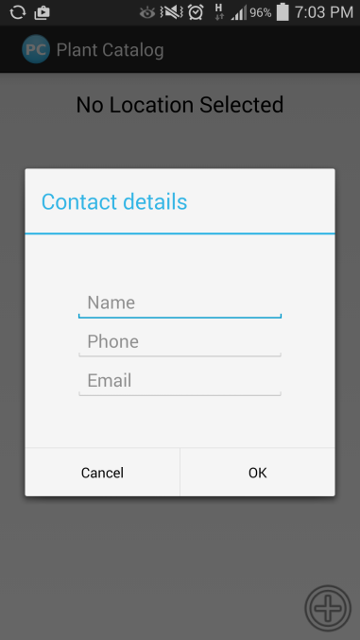

(IMG02)  
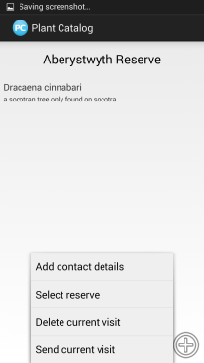

(IMG03)  
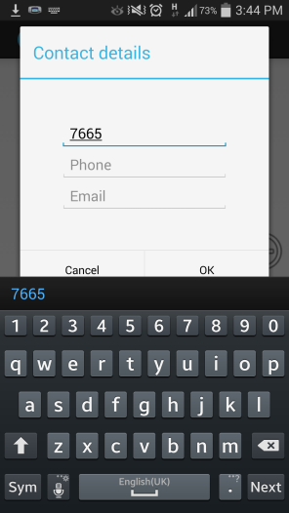

(IMG04)  
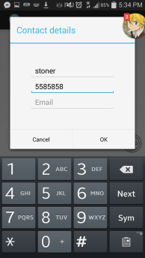

(IMG05) (IMG06)  
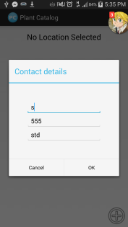 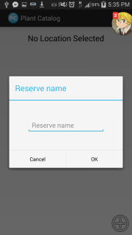

(IMG07)  
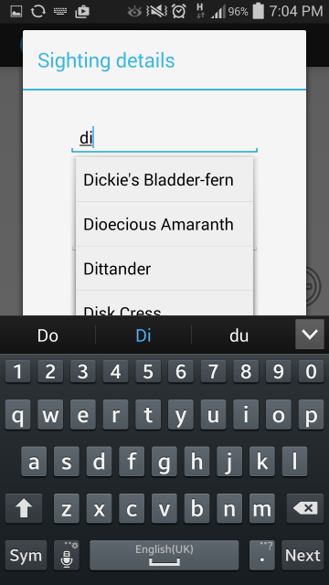

(IMG08)(IMG09)  
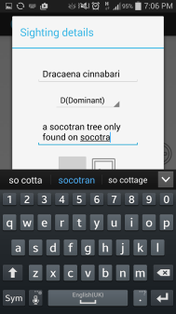 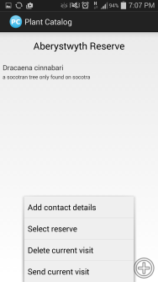

(IMG10)  
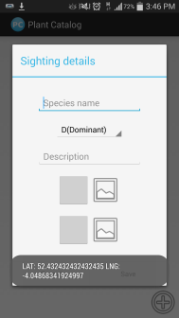

(IMG11)  
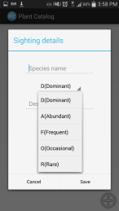

(IMG12)  
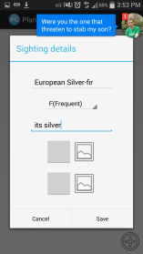

(IMG13)  
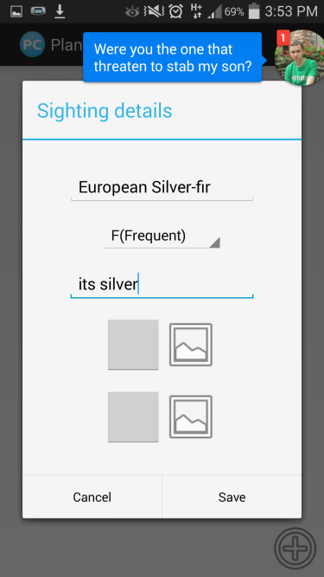

(IMG14)  


(IMG15)  


(IMG16)  


(IMG17) (IMG18)  
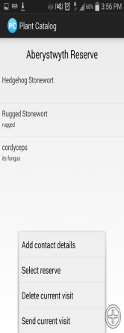 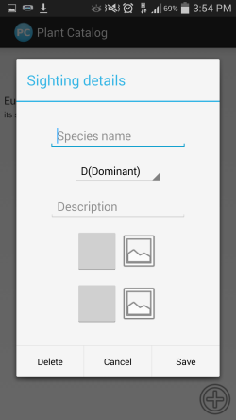

(IMG19) (IMG20)

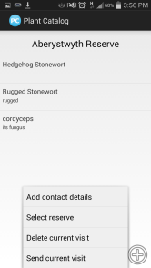 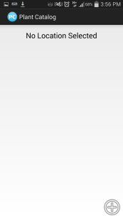

(IMG21)  


(IMG22) (IMG23)  
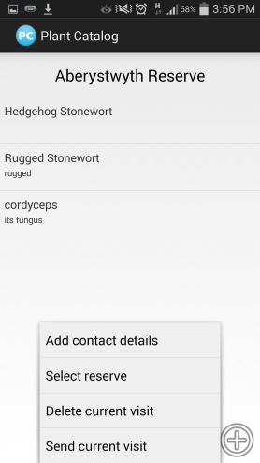 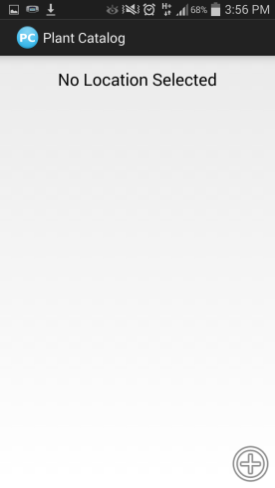

(IMG24)  
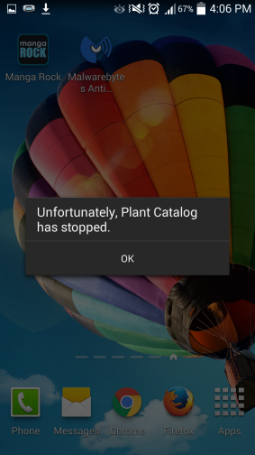

|  |  |  |  |
| --- | --- | --- | --- |
| Version | Date | Changes Made | Changed by |
| 1.0 | 15.02.2015 | Original document. | cpm6 |